Business Model Description
Describe your business and business model in 2 paragraphs.
The subsequent text looks at defining a specific business model through the various lenses of the modelH canvas.

Buyer (Customer Segment)
Buyers are the customers a business model sells to – and may also be the Users.
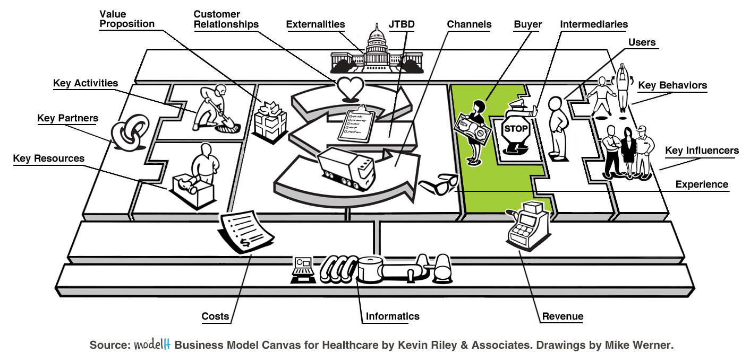
Who pays you (Buyer) for the value you create and what is their relationship to you and the User? Is the Buyer also the User of the product or its derivative?

Who are your most important customers (Buyers)?
Primary, Secondary, Tertiary

What nomenclature is used to define the User in your business model?
Patient, Provider, Member, Insurers, Customer, Consumer, Other

How does your Buyer make a purchase decision? What defines them as a lead versus a customer?

Users (Customer Segment)
Users are the customers that a business model serves.
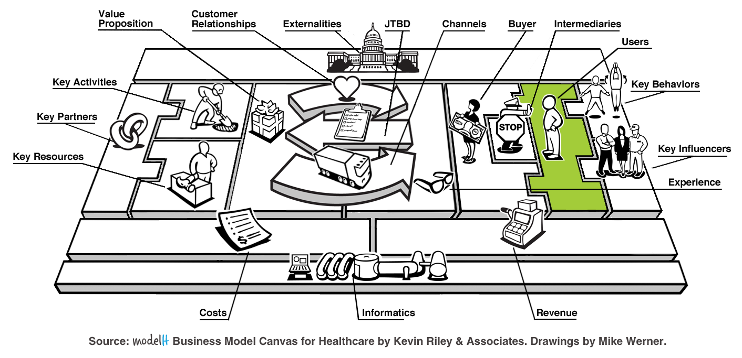
For whom are we creating value? Who is our target customer (User)?

What nomenclature is used to define the User in your business model?
Patient, Provider, Member, Insurers, Customer, Consumer, Other

What segmentation model is used to distinguish between various User types?
by Geography (where they live, shop, or receive care, etc.)
by Life-Stage (life stage, age, sex, income, occupation, etc.)
by Life-Condition (by health status, lifestyle choices, social class, interests, hobbies, etc.)
by Life-Style (by their Job-to-be-done, how they use the product, brand loyalty, etc.)

Intermediaries
Intermediaries affect how a company’s Value Proposition is seen and paid for by the Buyer.
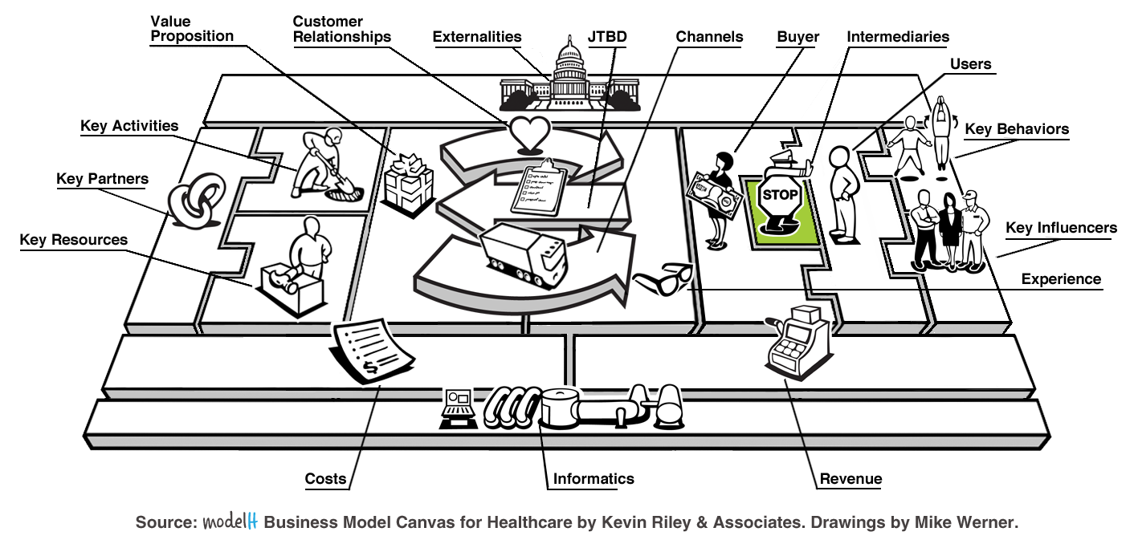
What Intermediaries influence the Buyer in your business model?

What Intermediaries derive value from your Value Proposition?

Does the Intermediary act on behalf of the Value Proposition, the Buyer or themselves?

What Costs does the Intermediary add to the business model?
Channel, Customer Relationship, Experience, Platform, etc.

Can the Intermediary be disintermediated? Should they be disintermediated?

If your business model is an Intermediary within another describe how.

If so, can you be disintermediated?

Job-to-be-done (JTBD)
Jobs-to-be-Done (JTBD) are the high-level goals the Buyer & User are trying to accomplish.
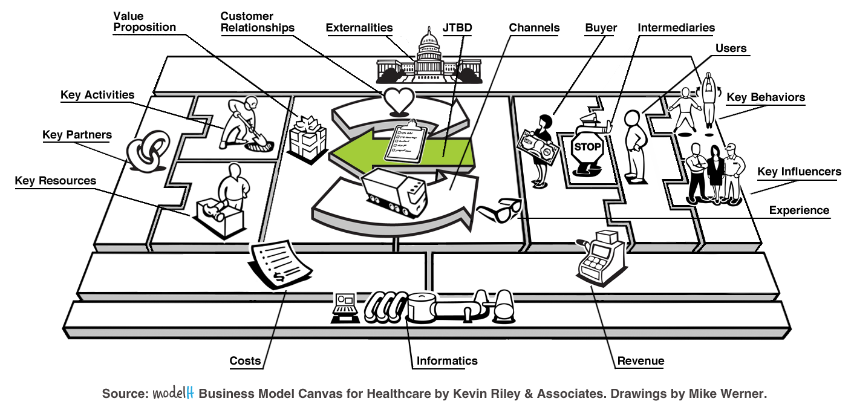
What are the customer’s jobs-to-be-done (JTBD)?
Construct your Buyer and User’s jobs-to-be-done using the following template:

JTBD: I want to … action words + object of action + context
Approach | How do they go about solving the JTBD now?
Benchmark | What do they compare their current approach to now – good or bad?
Criteria | What criteria do they use to judge of the effort and experience?
Barriers | What prevents them from trying a different approach?
Value | What creates value in their mind in regards to this JTBD?

Value Proposition
Value Propositions are the products & services offered to a customer to solve their JTBD.
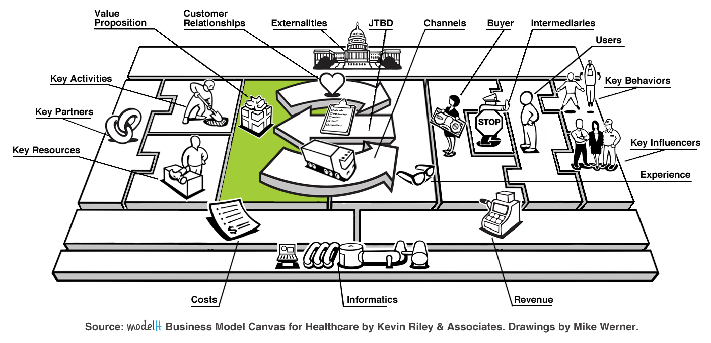
Describe your Value Proposition Statement in one sentence?
Construct your Value Proposition using the following statement template:
My company, __(insert name of company)__, offers __(a defined offering)__ to help __(a defined audience)__ (solve a problem)__ with __(secret sauce)__.

Which jobs, pains, and gains are addressed in your Value Proposition? Which ones are not?
Construct your Value Proposition using the following template:
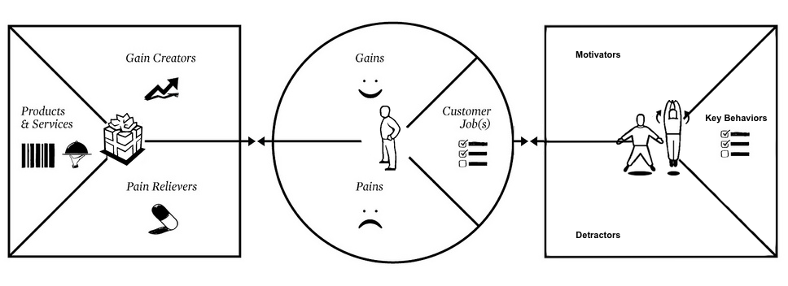
What bundles of products and services are offered in your Value Proposition?

Describe the process and time required to deliver your Value Proposition?

Key Behaviors
Key Behaviors are the activities required of the User to complete their JTBD.
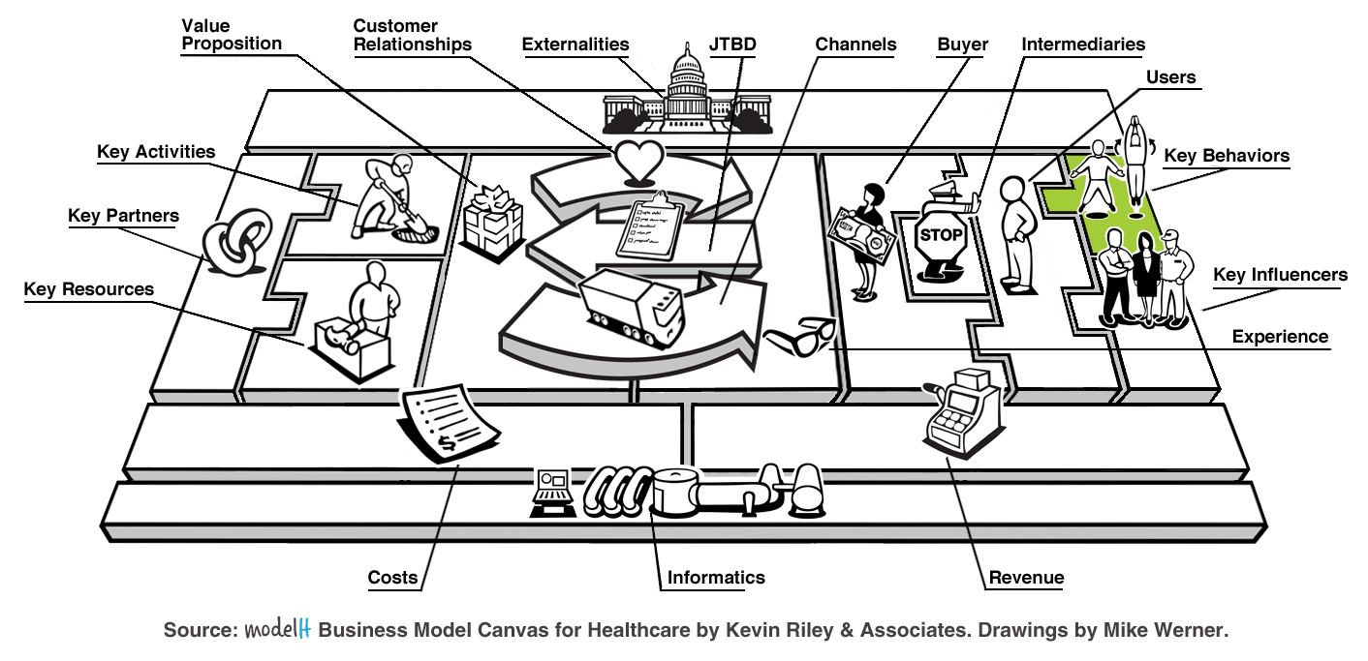
What Key Behaviors are required for a customer to complete their JTBD?

What negative behaviors must the User overcome? Which result from your business model and how can they be removed?

How difficult will adoption of the Key Behaviors be for the User?

Which of these Key Behaviors require stimulus from Key Influencers?

Which of these Key Behaviors are affected by Intermediaries and how?

What behavior change model(s) are you using to drive the Key Behaviors?
Expectancy Theory – Vroom
Persuasive Design - Fogg
Social Cognitive Theory / Self-Efficacy – Bandura
Theory of Reasoned Action / Planned Behavior - Fishbein & Ajzen
Transtheoretical Model / Stages of Change – Prochaska
Hierarchy of Needs – Maslow
Other

Key Influencers
Key Influencers affect the User’s understanding and ability to complete of their JTBD.
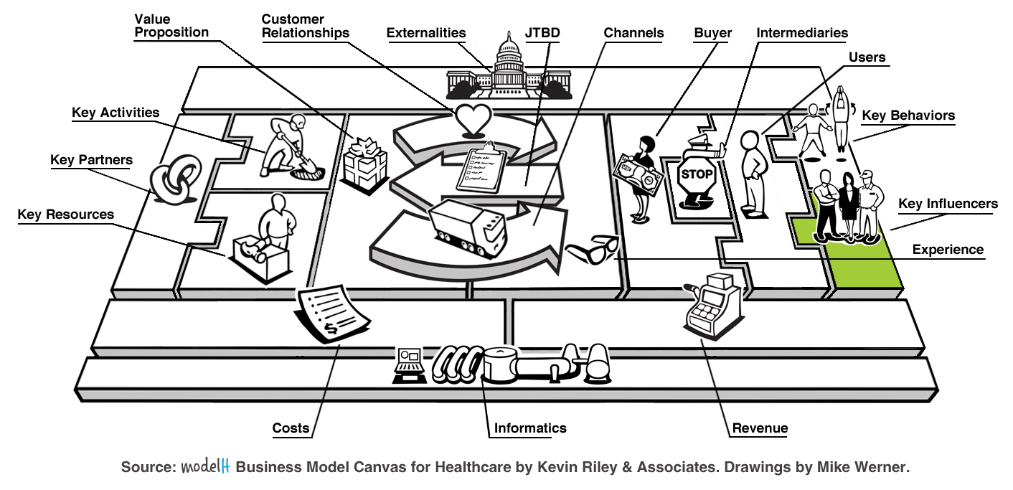
What Key Influencers are required for Users to complete their JTBD? What parts of the JTBD do Key Influencers affect?

What Key Influencers are required for Users to realize your Value Proposition? What parts of the Value Proposition do Key Influencers help deliver?

What is required for Key Influencers to understand your business model?

How do Key Influencers communicate with the User?

How can you activate Key Influencers without adding Cost?

Channels
Channels are the way a company brings its Value Proposition to market.
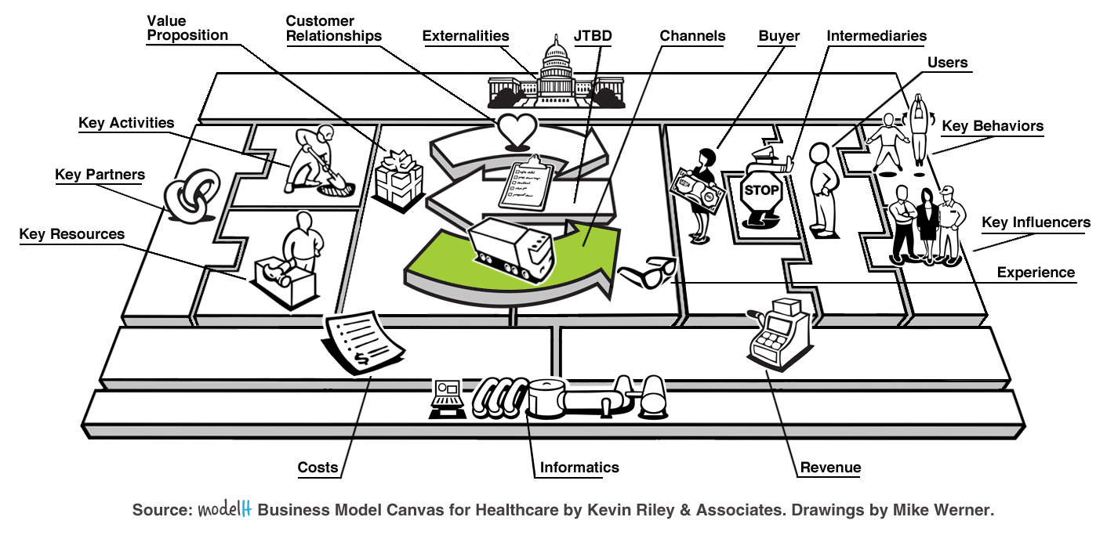
Through which Channels are you connecting with your Buyers & Users?
Owned: Direct (mail, telephone, etc.), Physical (store), Digital (email, chat, text, etc.), Online (web, purl, etc.), Other
Indirect: Direct (mail, telephone, etc.), Physical (store), Digital (email, chat, text, etc.), Online (web, purl, etc.), Other

Through which Channels do your Buyers & Users want to be reached?

Describe any multi-channel “threads” your Customer Segments use and how?

Describe how are you integrating your Channels into your customer’s routines?

Describe how you engage Intermediaries in your Channels?

Describe how you engage Key Influencers in your Channels?

Customer Relationships
Customer Relationships are connections a company creates with their Buyers and Users.
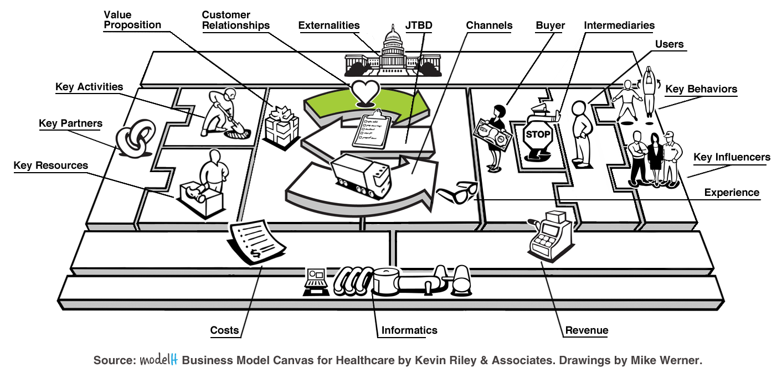
What type of relationships do your Customer Segments expect you to establish and maintain with them?
By personal assistance, self-service, automated services, co-creation, Other

Which relationships do your Intermediaries control?

Which relationships do your Key Partners control?

What type of relationship do your Intermediaries expect you to establish and maintain with them?

Which ones have we established and how are they integrated with the rest of your business model?

Experience
Experience is how both Buyers and Users perceive Channels and Customer Relationships.
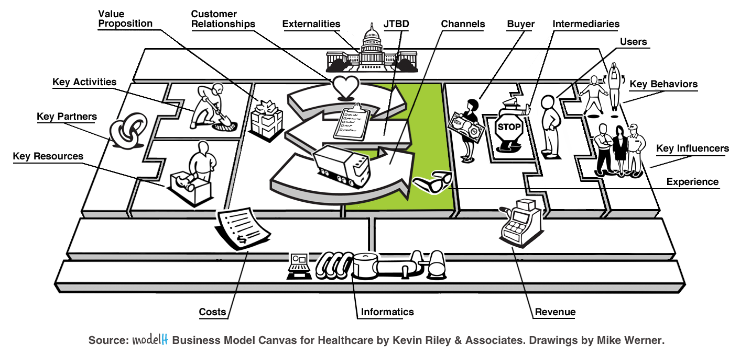
What is the lowest common denominator Experience your customer requires?

Where does your Experience exceed these minimum expectations?

Where does your Experience deceed these minimum expectations?

How can the Value Proposition be personalized based on Buyer & User needs?

Key Activities
Key Activities are the most important tasks required to create a Value Proposition.
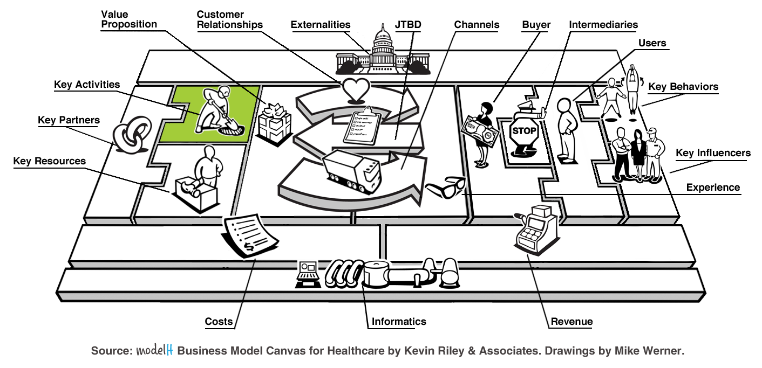
What Key Activities do your Value Propositions require?

How do you manage your Value Proposition creation?
Product development lifecycle, minimum viable product cycle, etc.

What Key Activities do your Channels require?

What Key Activities do your Customer Relationships require?

What Key Activities do your Revenue streams require?

Which of your Key Activities drive your Experience?

Key Resources
Key Resources are the internal actors required to deliver the Value Proposition.
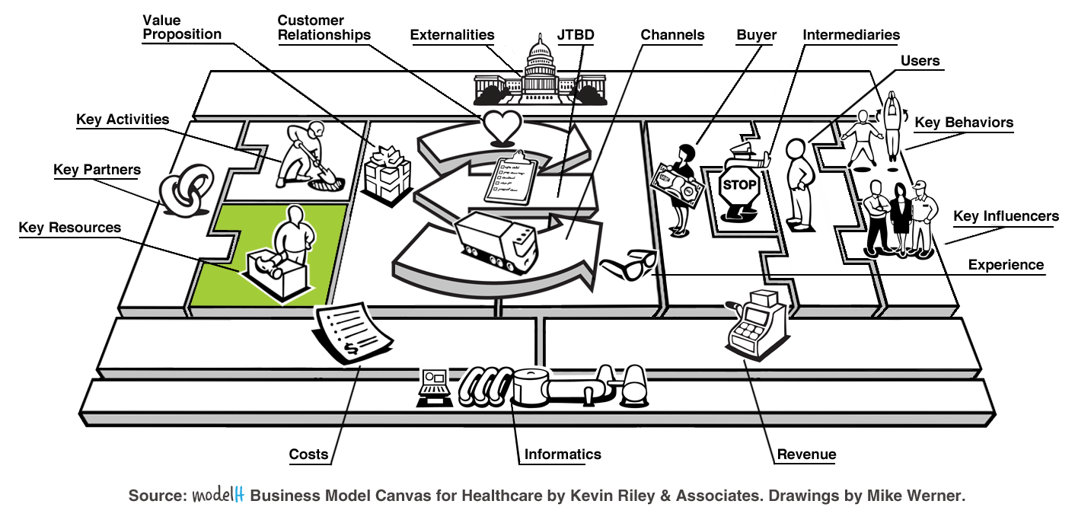
What Key Resources do your Value Propositions require?
Physical (buildings, machines, software); Intellectual (brands, patents, copyrights, customer databases) Human, Financial, Other

What Key Resources do your Customer Relationships, your Experiences, and your User’s Key Behaviors require?

What Key Resources do your Channels, Partners, Intermediaries and Influencers require?

What Key Resources do your Revenue streams require?

What Key Resources do your Costs require?

Key Partners
Key Partners are the external actors required to deliver the Value Proposition.
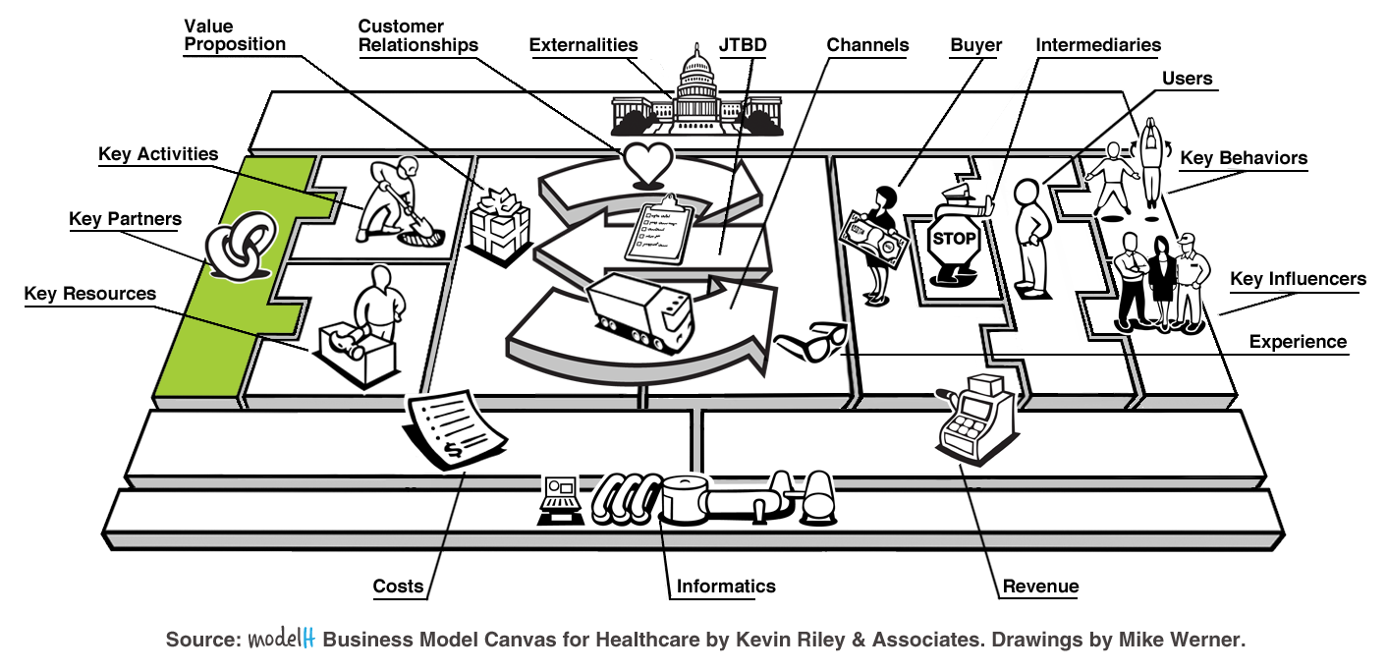
Who are your Key Partners and what Key Activities do they perform?

Which Key Resources are you acquiring from partners?

Are there any Intermediaries that you need to make into Key Partners?

Are there any Key Influencers that you need to make into Key Partners?

Costs
Costs are the most important financial drivers of a business model.
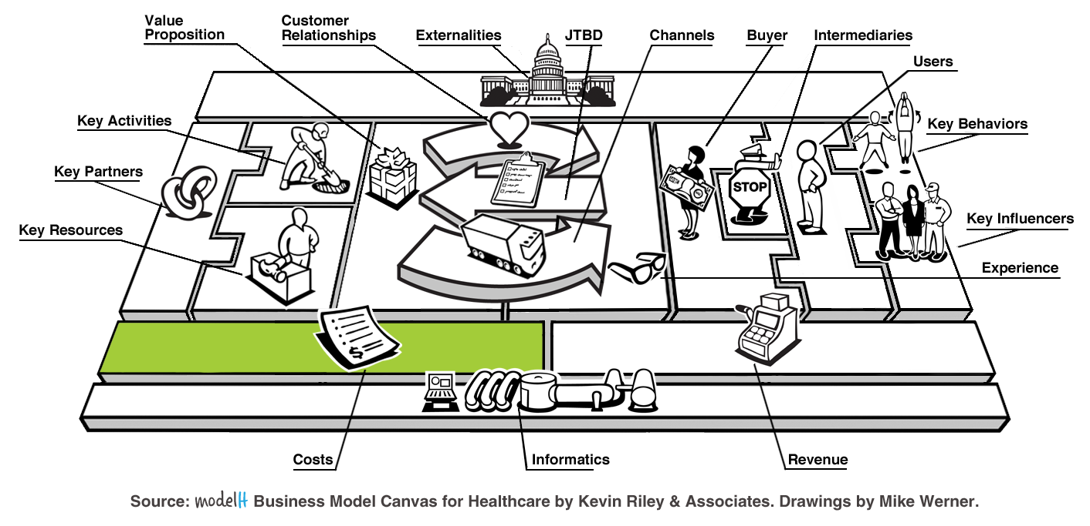
What are the most important fixed Costs inherent in your business model?

What are the most important variable Costs inherent in your business model?

What drives these Costs and which ones are controllable or reducible through economies of scale or scope?

Which Channels are most expensive?

Which Customer Relationships are most expensive?

Which Key Behaviors are most expensive?

Which Key Resources are most expensive?

Which Key Activities are most expensive?

Revenue
Revenue is the way a company makes money from its customers.
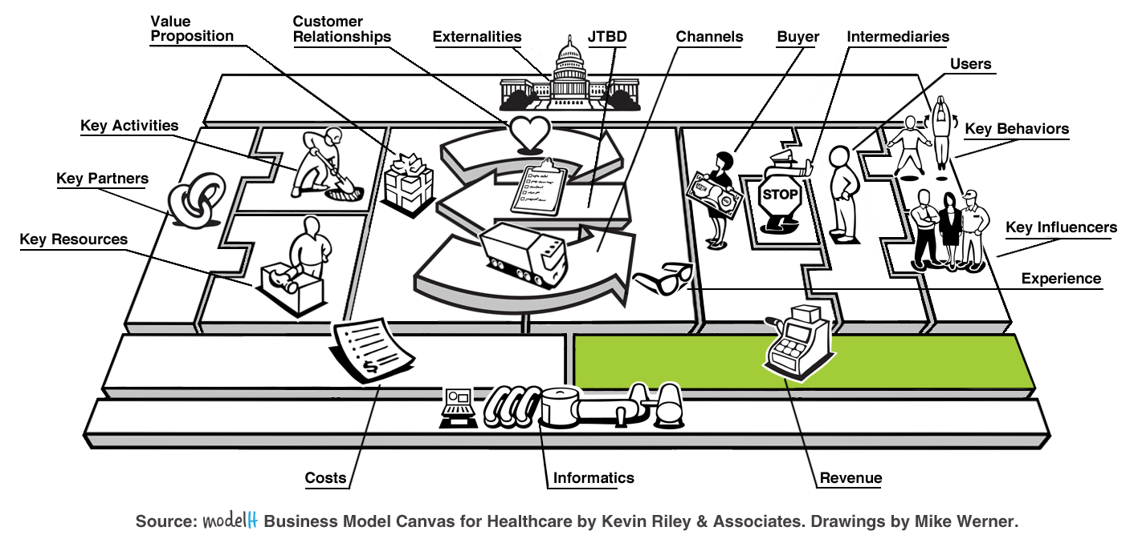
How will your business make money?
Traditional Model – sell a product or service from your own or from a Key Partner’s inventory
Value-Add Model – add value to the sale of a product or use of a service by another
Freemium Model – offer a minimum product and charge for pro features
Affiliate Model – direct traffic, leads or referrals to another
Subscription Model – pay a recurring fee and/or transactional fee to access the product
Virtual Goods Model – selling virtual goods online in a game or website
Advertising Model – high traffic websites sell ads for their traffic
Other

For what value are customers willing to pay? What do they currently pay for these services/items?

How are they currently paying? How would they prefer to pay?

What is the total addressable market size (TAM), or the revenue opportunity? The serviceable addressable market size (SAM)? The target market size (TM)?

What is the justification for your sales projections?

What is your revenue cycle and how you will manage it?

What is your pricing strategy?

Informatics
Informatics is the data and analytics needed to deliver and measure the Value Proposition.
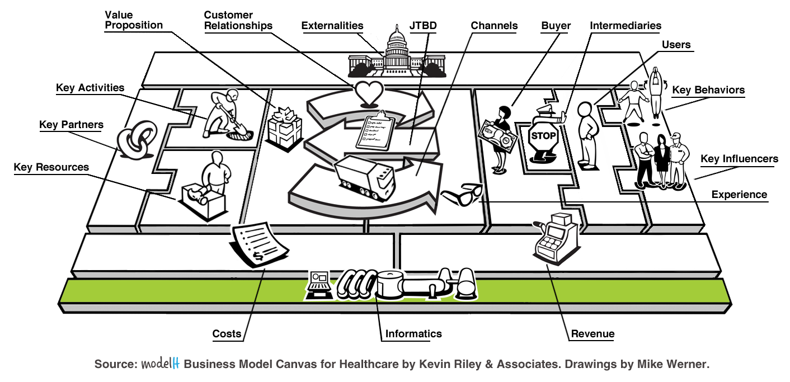What data is derived from Buyer & User interactions?

What systems are needed to capture that data?

How does your business model gain insight from Buyer & User interactions?

How does this insight drive additional Revenues?

How does this insight lower Costs?

Externalities
Externalities are the external forces and regulations imposed upon a business model.
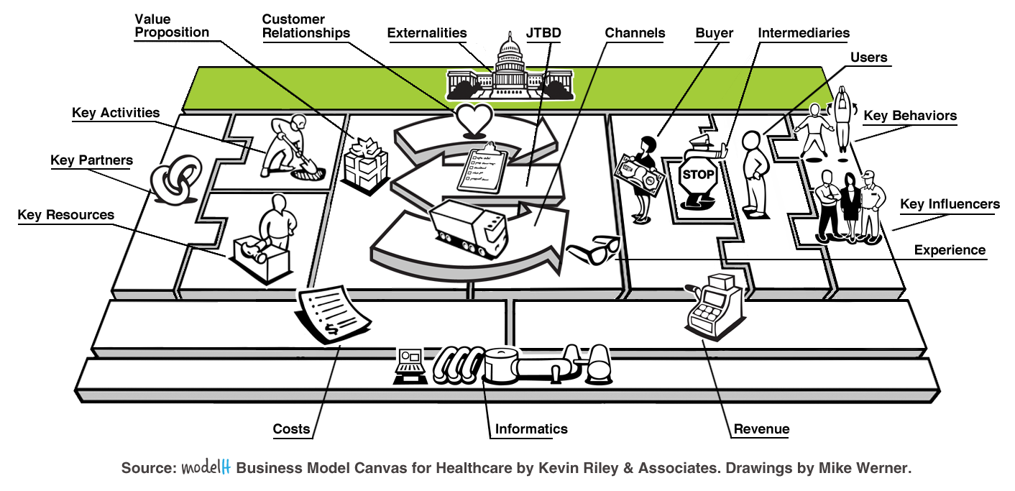
What Externalities put constraints on your business model?

How do these Externalities restrict your Buyers and Users?

How do these Externalities affect your User’s Key Behaviors?

How do these Externalities affect your Key Influencers?

How do these Externalities drive Costs?

How can these Externalities be turned into Revenue streams?

